**16-BIT SUBTRACTION:**

**EXP NO.6**

**AIM:** To write an assembly language program to implement 16bit subtrction using 8086 processor.

**ALGORITHM:**

1. Load 0000H into CX register (for barrow)
2. Load the data into AX (accumulator) from memory 2050
3. Load the data into BX register from memory 2502.
4. Subtract BX with accumulator AX.
5. Jump if no barrow
6. Increment CX by 1
7. Move data from AX (accumulator) to memory 2504.
8. Move data from CX register to memory 2055.
9. Halt

**PROGRAM:**

LHLD 2050

XCHG

LHLD 2052

MVI C,00

MOV A, E

SUB H

STA 2054

MOV A, D

SUB H

STA 2055

HLT

**INPUT:**

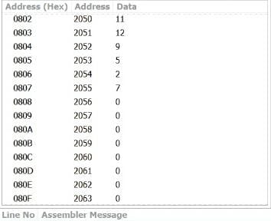

**OUTPUT:**

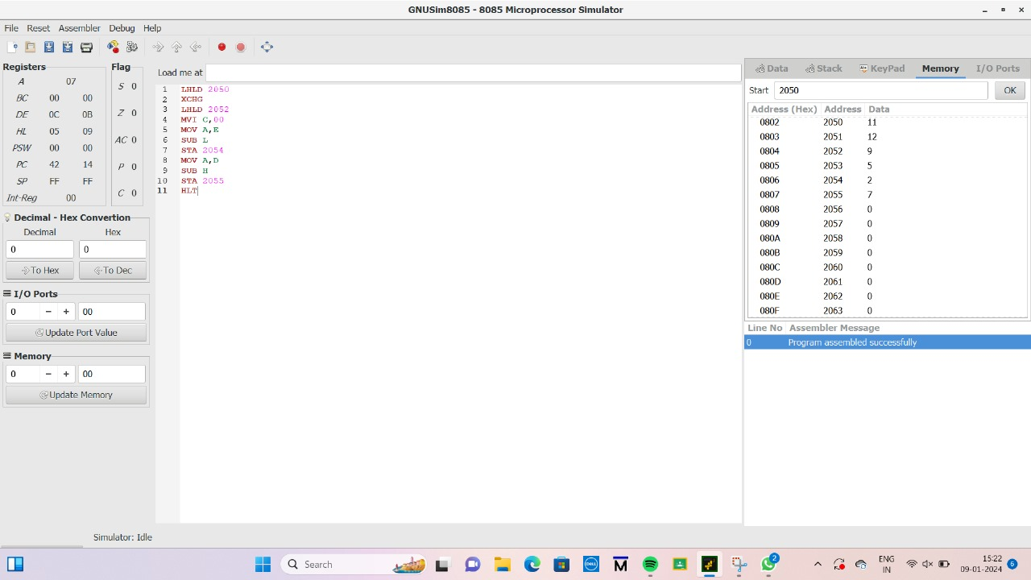

**RESULT:** Thus the program was executed successfully using 8056 processor simulator.